Titan Missile Technical Information

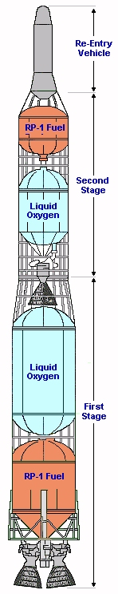 | The Titan was a spin-off from the Atlas Missile Program. The Atlas was essentially a giant fuel tank with guidance equipment and warhead on the nose and engines at the rear. The fuel tank was the structure. It was a single stage missile.  The Titan was a two stage missile. This necessitated an internal structure. Each of the two stages carried liquid oxygen and rocket propulsion fuel.  The most notable difference between the Titan-I and Titan II was the type of oxidizer and propellant each used.  Titan-I used liquid oxygen as an oxidizer. It was cryogenic, meaning it had to be kept at an extremely low temperature, generally around-1950C. It had to be stored in special refrigerated tanks and pumped aboard the missile before it was fired. Liquid oxygen is extremely volatile, inflammable, and very difficult to handle, especially within the confines of an enclosed missile silo.  SPECIFICATIONS  Length: 98 ft. 4 in.  Diameter: 10 ft. 0 in.  Weight: 221,500 lbs. at launch  Armament: Nuclear warhead  Engines: Two Aerojet-General liquid propellant boosters; an LR87 first stage engine of 430,000 lbs. thrust and a second stage of 80,000 lbs. thrust  Max. speed: 15,000 mph. / 13,904 knots  Max. range: 6,300 statute miles / 5,475 nautical miles  Max. altitude: 620 statute miles / 538 nautical miles  Cost: $1,502,000

Titan-I Launch Sequence

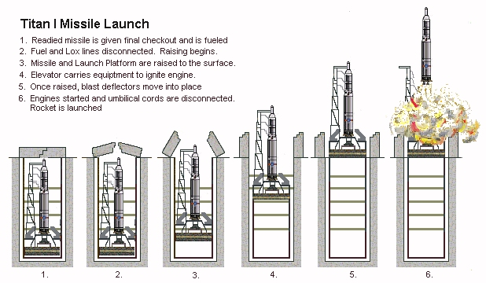
The launch sequence took approximately 15 minutes. After receiving a launch order, the crew filled the missile's tanks with 200,000 pounds of liquid oxygen and RP-1. After the missile was fueled, it rode to the surface on the silo elevator and then was fired. The flight began with the ignition of the large first-stage engine that burned for 134 seconds and propelled the missile to an altitude of 35 miles.

As the first stage expired and fell away, the second stage fired; it burned for another 156 seconds, boosting the missile to an altitude of150 miles and a velocity of 22,554 feet per second.

After the second stage fen silent, two small Vernier engines fired for an additional 50 seconds making final course corrections to the trajectory.

After the Vernier engines burned out, the reent6 vehicle carrying the war-head followed a ballistic trajectory, and at the apogee of its flight soared to an altitude of 541 miles above the earth's surface. Time elapsed for a 5,500 mile flight: 33 minutes.

